CS 4185 Multimedia Techs & Appls
Course Project Report
ZHU Fu 57827327

1 Introduction
For the course project to improve the performance of the media retrieval system, I took advantage of the deep learning model VGG16 which is a popular CNN (Convolutional Neuron Network) model on media processing and identifying. Combined with the VGG16, different traditional media feature extracting methods are also involved. Color moments, Textures and Shape features are all considered to support the deep learning model, which will be expanded later. All mentioned above excluded VGG16 are realized in support of the OpenCV library.

2 Deep Learning Model
For the VGG16 model, the average pooling (Fig 1) is used to limit the effect of the noise and to improve the cooperation between the deep learning model and the traditional approaches. In addition, average pooling is also the first choice for image retrieval in recent applications. Using the pretrained weight of ImageNet, VGG model could be the best fit of the project.
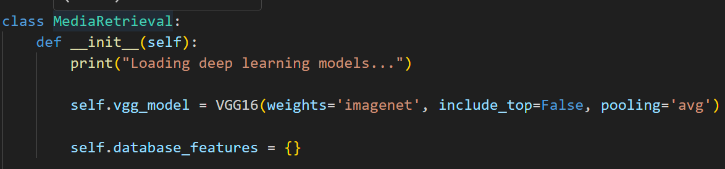
Figure 1
To extract the features, due to the input size requirement of VGG16, the images should be resized to 224, 224. This is also the reason why the traditional feature extracting been used: to support the detailed image feature extractions. Still, normalization is necessary for the model stability, so L2 normalization is widely used in the project to keep the functions’ stability and robustness by turning feature vectors into unit vectors. (Fig 2)
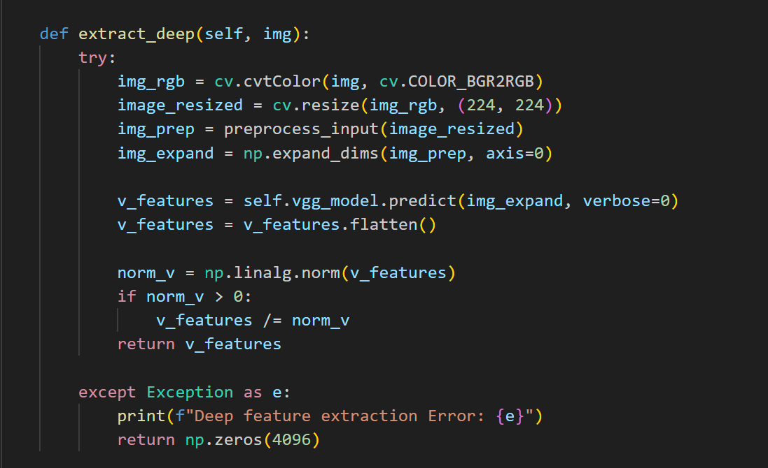
Figure 2

